****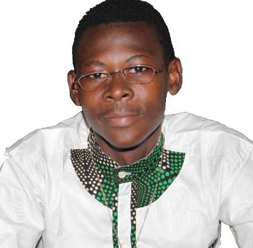

**Bachelor Student in Electrical Engineering.**

I enjoy studying electro-mechanics, along with broadening my horizon with regards to the topics of entrepreneurship, programming, and financial markets.

# Personal Information

**Birth date:**

25-08-2001

**Birth place:**

Koudougou, Burkina Faso

**Adress:**

Koudougou, sector 06/Burkina Faso

**Phone:**

+226 73639550 | +226 75385005

**E-Mail:**

ablassezoungrana27@gmail.com

# Skill Highlights

* Microsoft Windows & Office
* C-Programming

# Languages

* Moore: native
* English: advanced
* French: advanced

# Experience

**Student representative at (Moukassa)**

Tasks:

* Organize events
* Train theater to the students
* School newspaper writer

# Education

**B.Sc. Electrical Engineering** 09**/**2020 – today

Burkina Institute of Technology, Koudougou

Focus : - Renewable Energies

- Management & Entrepreneurship

**Baccalaureate** 10/2017 – 08/2020

Collège Saint Joseph Moukassa, Koudougou

Grade: 10.54 / 20

**O’ level** 10/2013 – 06/2017

Collège Saint Joseph Moukassa, Koudougou

**Certificate of primary school** 10/2007 – 06/2013

Ecole Sogpelsé, Koudougou

# Certifications

**Certification in Digital Marketing**

Content: Marketing strategies and tools

**Certification in Entrepreneurships**

Content: Business idea generation and Self employment

**Certification in Basketball**

Content: Play as a professional

**Signature**

Ablassé Wendkouni ZOUNGRANA